|  |  |
| --- | --- |

| Functional Specification Document |
| --- |
| For  Project RISE - Forte |
| New Business, Claims & Customer View/Update |
| |  |  | | --- | --- | | Version | 0.1 | | Status | Draft | |

Document History & Sign-Off Page

Document History

| **VERSION** | **SUBMISSION DATE** | **DESCRIPTION** | **AUTHOR(S)** | **REVIEWED BY** | **REVIEW DATE** |
| --- | --- | --- | --- | --- | --- |
| 0.1 | 05-01-2020 | Draft Version FSD | Shailendra Singh |  |  |
|  |  |  |  |  |  |
|  |  |  |  |  |  |
|  |  |  |  |  |  |
|  |  |  |  |  |  |
|  |  |  |  |  |  |
|  |  |  |  |  |  |

Sign-Off

|  |  |  |  |
| --- | --- | --- | --- |
| **Name** |  | **Role** |  |
| **Title** |  | **Date** |  |
| Signature | | | |
| **Name** |  | **Role** |  |
| **Title** |  | **Date** |  |
| Signature | | | |
| **Name** |  | **Role** |  |
| **Title** |  | **Date** |  |
| Signature | | | |
| **Name** |  | **Role** |  |
| **Title** |  | **Date** |  |
| Signature | | | |
| **Name** |  | **Role** |  |
| **Title** |  | **Date** |  |
| Signature | | | |
| **Name** |  | **Role** |  |
| **Title** |  | **Date** |  |
| Signature | | | |

Table of Contents

Introduction 4

1) Purpose 4

2) Process Landscape - Scope 4

3) Reference 4

4) Technology Stack 4

5) Intended Audience 4

6) Assumptions 4

7) Exclusions 5

8) Proposed Benefits 5

New Business Overview 6

1. Roles and Responsibility of Actor 6

2. Initiation 6

New Business Detailed Requirements 7

1. System Step – Receive Primary Info 7

2. System Step – Check Duplicate 7

3. System Step – Check Customer Details 8

4. System Step – Receive USSD Data 8

5. System Step – Check Customer Details Periodically 9

6. System Step – Update NB Details 10

7. System Step – Pending For Customer Details 11

Customer View/Update Overview 12

1. Process Specification Diagram 12

2. Roles and Responsibility of Actor 12

3. Initiation 12

Customer View/Update Detailed Requirements 13

1. Manual Step – Customer View and Update Screen 13

2. Manual Step – Approve Changes in Customer Details 14

Claims Overview 16

1. Process Specification Diagram 16

2. Roles and Responsibility of Actor 16

3. Initiation 16

Claims Detailed Requirements 17

1. Manual Step – Claims Initiation UI 17

2. Manual Step – Verify and Updated Claim Details 19

3. System Step – Pending For Claim Details 20

4. Manual Step – Review Claim 21

5. System Step – Check Authority Limit 22

6. Manual Step – Approve Claim 22

7. Manual Step – Confirm Payment 23

Report Requirement Scope 24

Report Requirement Requirement 25

# Introduction

## Purpose

The purpose of this project is to provide micro insurance cover in Laos by Forte Insurance, whenever a customer purchases any Insurance linked mobile recharge package. Lao Telecom is the telecom partner with Forte Insurance. The insurance will cover Hospitalization and Accidental for a defined period as per the validity of the recharge done on the mobile number. The cover of insurance is applicable from the following month and not for subsequent month.

The purpose of this document is to highlight the To-Be Process for New Business process of Forte Micro insurance. The Intention of the document is to have a clear understanding of the to-be process requirements, which will be instrumental to arrive at the to-be process design and development. The document should be able to capture the current challenges in the process and proposed improvements.

The process will be covered in both aspects of the end to end business process as well as, in terms of the User Interface requirement. The document doesn’t cover business use cases; instead it will explain the system capabilities at various juncture of NB, Claims or Customer Servicing life cycle.

## Process Landscape - Scope

Following processes are considered for implementation in this project –

1. New Business
2. Claim
3. Customer View and Update

## Reference

List all the related references e.g. procedures, forms, templates, standards, guidelines & checklists

|  |  |  |
| --- | --- | --- |
| **Reference No.** | **Title** | **Final Reference Doc** |
| 1 | Project Proposal |  |
| 2 | Claims Process Flow |  |

## Technology Stack

1. Process Engine : Flowable
2. Document Repository : DB/SAN
3. Case Management : Flowable UI
4. External System Integration : Lao Telecom, SMS Gateway

## Intended Audience

1. Forte Business Team
2. Forte IT Team
3. CL Analysts & Developers

## Assumptions

1. The processes have been documented as per the information provided by Forte Project Team and Lao Telecom who interacted with the Author. Assumption has been made that this information provided is complete and correct.
2. Roles for each manual step need to be finalized here. In case they are not finalized due to unforeseen circumstances, then they should be finalized during technical spec preparation and review.
3. At certain stages across the process, the design approach has been based on the proposed modifications in the operating procedures and proposed enhancements (services) in the interfacing application. In case these proposed modifications/enhancements are not achieved, then an assessment will have to be made to identify its impact on this process and suitable alterations will have to be incorporated in the design to cater to future requirements.
4. The grouping of the Processes and Sub processes here are done on the basis of business flow. During implementation, as per technical feasibility and requirements, the development team may choose to merge these flows into single or further break them into sub flows, as required.
5. Reporting Requirement mentioned in this document are in accordance with customer’s expectation. However, each report will be technically analysed during the design phase.

## Exclusions

1. The processes covered in the documentation are limited to Forte and does not incorporate processes of other Business Channels such as Agents, Brokers etc. operating under/with Forte.
2. Policies or procedures of various process participants (such as Agent, Managers Etc.) to complete additional work (such as looking into various reports and taking action in any other system etc.), All such processes are not documented herein.
3. This process documentation covers areas of business process only. This does not cover the study of other systems used by Forte. E.g. Mars, Call center application etc.
4. No customization will be done on inbuilt capabilities of Flowable and feature available as out of the box will be utilised to design the solution.
5. If the telecom operator assigns a mobile number to a different customer than the handling of such customers will be done outside workflow solution.

## Proposed Benefits

* End to end standardized process for New Business and Claims
* Overall view of the customer information available on one click
* Time saving with the help of auto generated reminders to get customer details.
* Better customer service by sending notification to customer on key milestones.
* Key reports without putting manual effort.

# New Business Overview

## Roles and Responsibility of Actor

**Process Participants**

To complete end-to-end processing of Lao Micro insurance process, multiple participants across various departments perform vital functions. A list of all such participants is provided below –

|  |  |  |  |
| --- | --- | --- | --- |
| **Process** | **Step Name** | **Actor** | **Role** |
| **New Business** | Receive Primary Info | System |  |
|  | Check Duplicate | System |  |
|  | Check Customer Details | System |  |
|  | Receive USSD Data | System |  |
|  | Check Customer Details Periodically | System |  |
|  | Update NB Details | Manual | Call Center Agent |
|  | Pending For Customer Details | System |  |
|  |  |  |  |
| **Claims** | Claims Initiation UI | Manual | Inbound Agent, Claim Agent, Claim Manager |
|  | Verify And Updated Claim Details | Manual | Claim Agent |
|  | Pending For Claim Details | System |  |
|  | Review Claim | Manual | Claim Manager |
|  | Check Authority Limit | System |  |
|  | Approve Claim | Manual | General Manager |
|  | Confirm Payment | Manual | Finance Manager |
|  |  |  |  |
| **Customer View/Update** | Customer View & Update UI | Manual | Inbound Agent |
|  | Approve Changes In Customer Details | Manual | QA Manager |

## Initiation

Lao Telecom customers will have an option non insurance or insurance linked mobile recharge packages or new connection. Whenever a customer selects insurance linked packages then LAO Telecom will send the mobile number and package details to workflow solution. Workflow will then process the details further based on the information available. There will be separate handling for mobile numbers with and without detailed information.

# New Business Detailed Requirements

## System Step – Receive Primary Info

**Purpose of this Step**

Purpose of this step is to receive Mobile number and package from Lao Telecom using a webservice.

**Role**

System

**Step Description**

1. Using API, Lao Telecom will send the “Mobile number”, “Selected package” and “Time Stamp” to workflow. Case will be routed for Duplicate Check system step.

**Decision**

Not Applicable

**User Interface Requirements**

Not Applicable

**Integration Requirements**

Lao Telecom

**Exception Rules**

Lao telecom system to build a retry mechanism incase service response is not available from workflow.

**Remarks**

None

## System Step – Check Duplicate

**Purpose of this Step**

After receiving the mobile number and package, workflow shall check whether the service request received from Lao Telecom, is for a new customer or an existing customer.

**Role**

System

**Step Description**

1. Workflow shall maintain unique records for each mobile number in the database.
2. When Lao Telecom sends a record then system shall check whether a record already exists for the mobile number. The checking will be based on :
   1. Phone number : Customer Mobile Number
   2. Package : Package/Plan selected by customer for the mobile number
   3. Timestamp: Timestamp at which recharge was done.
3. If all the above three values are :
   1. Same for more than one service requests, then no further action is required in workflow.
   2. Different, then system will check for customer details in the database (as explained in next step)

**Decision**

Not Applicable

**User Interface Requirements**

Not Applicable

**Integration Requirements**

None

**Exception Rules**

Lao telecom system to build a retry mechanism incase service response is not available from workflow.

**Remarks**

None

## System Step – Check Customer Details

**Purpose of this Step**

After checking the duplicate records, workflow will check whether the details of the customer are available before sending the SMS that needs to be sent to customer.

**Role**

System

**Step Description**

1. Workflow shall check for the below details in the database for each customer based on mobile number:
   1. First Name
   2. Last Name
   3. Gender
   4. Date of Birth
   5. ID Type
   6. ID Number
2. Workflow shall call the service of SMS gateway so that the SMS is sent to the customer
   1. All the above details are available: SMS will be sent with insurance details.
   2. Data is not available in any of the fields: SMS will be sent to request details. This is a scenario where either the customer is new or the customer has not updated the details. In the SMS, there needs to be a link for user to update the details. Link will lead the customer to a screen where all the details mentioned in point 1 can be submitted.
3. The SMS will be sent based on the information that is maintained in database for each mobile number. Package Info and Following details needs to be maintained:
   1. Package ID
   2. Premium Per Reload that needs to be collected
   3. Maximum Monthly Collection for the package
   4. Total Premium Collected
   5. Insurance amount covered for Hospitalization
   6. Insurance amount covered for Personal Accident

Premium information is provided below.



**Decision**

Not Applicable

**User Interface Requirements**

Not Applicable

**Integration Requirements**

SMS Gateway

**Exception Rules**

System to have a retry mechanism to re-execute the checking in case there is an internal error.

**Remarks**

None

## System Step – Receive USSD Data

**Purpose of this Step**

Purpose of this step is to receive customer details from Lao Telecom using a webservice. The service will be called by Lao Telecom at any point of time. Hence, it has not been added in the process flow diagram.

**Role**

System

**Step Description**

1. Using an API call, Lao Telecom will send the below information to workflow.
   * Mobile Number
   * Preferred Language
   * First Name
   * Last Name
   * Gender
   * Date of Birth
   * ID Type
   * ID Number
   * Nominee Name
   * Relationship with Nominee
   * Nominee Contact No
2. Once the details are sent from Lao telecom to workflow then the information will be stored in database so that system will not check for customer details periodically for such mobile numbers.
3. Once the details are updated then a SMS will be sent to the customer about successful update of details.

**Decision**

Not Applicable

**User Interface Requirements**

Not Applicable

**Integration Requirements**

Lao Telecom

**Exception Rules**

Lao telecom system to build a retry mechanism incase service response is not available from workflow.

**Remarks**

None

## System Step – Check Customer Details Periodically

**Purpose of this Step**

A scheduler will be built which will run at a predefined interval every day, to check whether mandatory fields are available of all the customers. Based on the available details, reminder SMS will be sent to customer. The timing of the scheduler will be defined after the design stage.

**Role**

System

**Step Description**

1. Workflow shall check for the below details in the database for each customer based on mobile number:
   1. First Name
   2. Last Name
   3. Gender
   4. Date of Birth
   5. ID Type
   6. ID Number
2. If the any of the above data is not available then System shall send a reminder SMS.
   1. 1st Reminder: SMS will be sent for all policies after 3 days from the 1st SMS was sent to get customer details (as mentioned in 3.2.ii above).
   2. 2nd Reminder: SMS will be sent for all policies after 5 days after the 1st SMS was sent to get customer details.
3. If the customer details are available then scheduler will not pick such policies to trigger reminder SMS.
4. In scenarios where 2 Reminder SMS are already sent to the customer then workflow shall create a work item after 2 days from the 2nd Reminder sent date. The work item will be assigned to Call Center Agent team for further action.

**Decision**

Not Applicable

**User Interface Requirements**

Not Applicable

**Integration Requirements**

SMS Gateway

**Exception Rules**

Not Applicable

**Remarks**

None

## System Step – Update NB Details

**Purpose of this Step**

In this step, call center agent are expected to manually call the customers and update the details in the workflow solution.

**Role**

System

**Step Description**

1. User will login to Flowable UI.
2. After login, following details shall be shown to the user:
   1. Premium Collected
   2. Mobile Number
   3. Date and Time of workflow
   4. Case Open Since (count)
3. When User takes ownership of the case and clicks on a work item then a UI will be displayed with the below set of fields:

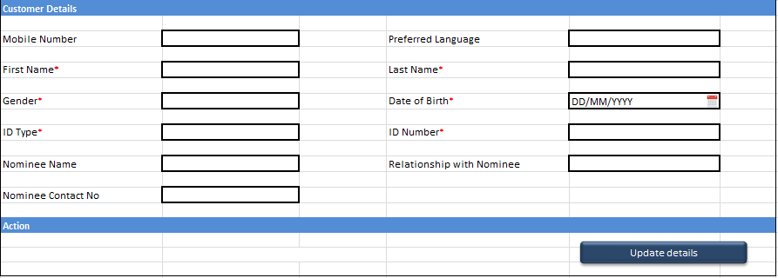

1. Below are the field level information shown in the screen:

|  |  |  |  |  |
| --- | --- | --- | --- | --- |
| **Field Name** | **Type** | **Details** | **Selection** | **Character** |
| Mobile Number | Non Editable | Auto populated | Mandatory | 13 |
| Preferred Language | Dropdown | English, Lao | Optional |  |
| First Name* | Free Text |  | Mandatory | 30 |
| Last Name* | Free Text |  | Mandatory | 30 |
| Gender* | Dropdown | Male, Female, Others | Mandatory |  |
| Date of Birth* | Calendar | DD/MM/YYYY | Mandatory |  |
| ID Type* | Dropdown | License, Passport, Family Card, National ID | Mandatory |  |
| ID Number* | Free Text |  | Mandatory | 15 |
| Nominee Name | Free Text |  | Optional | 60 |
| Relationship with Nominee | Dropdown | Spouse, Father, Mother, Son, Daughter, Brother, Sister | Optional |  |
| Nominee Contact No | Free Text |  | Optional | 13 |

1. Agent will call the customer to capture additional information in the screen and then click on “Update Details” button so that the information can be saved in workflow for future reference.
2. Under all the mandatory details are filled; user shall not be allowed to take “Details Updated” decision.

**Decision**

User will have the following decision on the case:

|  |  |
| --- | --- |
| **Decision Title** | **Step Outcome** |
| Suspend | Case will be sent to “Pending For Customer Details” step for the defined period. System shall show a calendar so that user can suspend the case for a defined period. Technical feasibility will be done for the calendar popup and same will be confirmed to Forte during the development stage. |
| Details Updated | The work item shall be closed and an SMS will be sent to the customer notifying that the details have been updated. |
| Closed | Work item will be closed because the customer was not reachable at all. |

**Integration Requirements**

SMS Gateway

**Exception Rules**

Standard UI exception handling will be build

**Remarks**

None

## System Step – Pending For Customer Details

**Purpose of this Step**

All cases for which agents had taken “Suspend” decision will be sent to “Pending for customer details” step.

**Role**

System

**Step Description**

System shall have the capability to allow Agents to manually resume the cases. Once the user resumes the case then it will go back to user’s basket in “Update NB Details” for further processing. Case can also resume once the suspension period is expired. Technical feasibility needs to be done on the suspension and resumption scenario and the same will be communicated to users after the development phase.

**Decision**

Not Applicable

**User Interface Requirements**

Not Applicable

**Integration Requirements**

Not Applicable

**Exception Rules**

Not Applicable

**Remarks**

None

# Customer View/Update Overview

## Process Specification Diagram

Here is the process specification diagram for Customer View and Update:

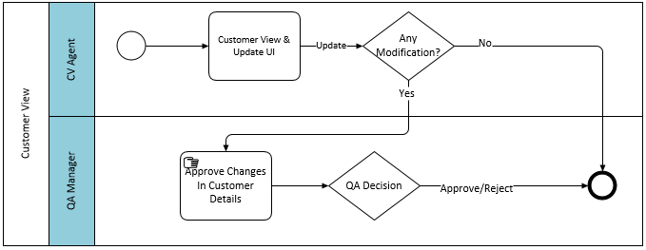

## Roles and Responsibility of Actor

The customer View and Update UI will be accessible by Inbound Agents.

## Initiation

Lao Telecom customers will have an option to buy non insurance or insurance linked mobile recharge packages for new or existing connection. Customers will call Forte customer care to get their details updated in the workflow solution. So the inbound agents will have a screen to query the customer information and also update the details for future reference.

# Customer View/Update Detailed Requirements

## Manual Step – Customer View and Update Screen

**Purpose of this Step**

Purpose of this step is to allow user to view and update the customer information available in the system.

**Role**

Inbound Agents

**Step Description**

1. Customer will contact call center to verify or update the customer information.
2. Call center agents will have access to the below UI from Flowable so that customer can view or update details as per the request:

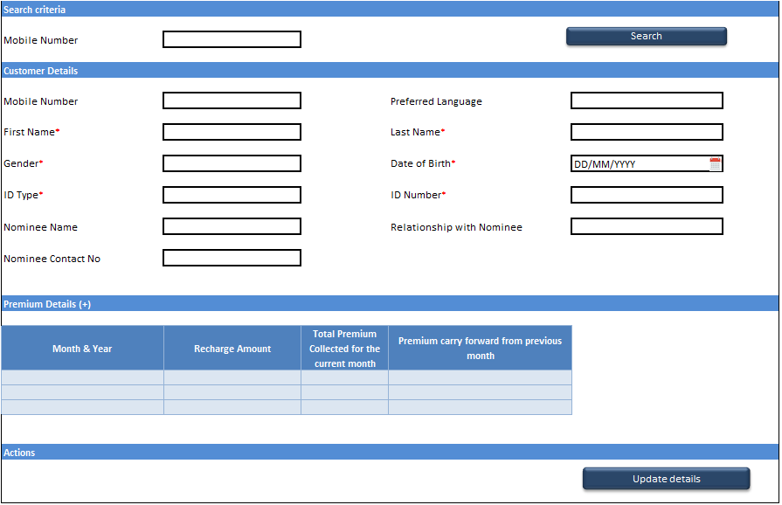

1. User shall be able to search the details based on “Mobile Number”.
2. Once the mobile number is entered and user clicks on search then three sections will be shown:
   1. Customer Details: Details will be same mentioned in New Business “Update NB Details” step.
   2. Premium Details :
      * Month & Year : Month and Year in which the recharge was taken by customer
      * Recharge Amount : Amount for which recharge was done on the mobile number
      * Total Premium Collected for the current month : Premium amount applicable for the month
      * Premium Carry forward from previous month : Excess premium collected from previous month
   3. Actions
      * Update Details: After entering details on the screen, user will click on “Update Details” button so that the details can be saved in database.
3. On click of “Search” button if there are no details related to customer then System will show a popup message “No record Found. Please verify the mobile number”.
4. If data in any field is changed then a case shall be triggered in manual step “Approve Changes in Customer Details”. If data is entered in any field for the first time then the details will updated without any work item creation and SMS will be sent to the customer.
5. The data should only be stored in DB once the changes are approved by QA Manager in the next step.

**Decision**

Not Applicable

**User Interface Requirements**

Not Applicable

**Integration Requirements**

Lao Telecom

**Exception Rules**

Not Applicable

**Remarks**

None

## Manual Step – Approve Changes in Customer Details

**Purpose of this Step**

Purpose of this step is to allow user to verify details entered by the agent in previous step.

**Role**

Inbound Agents

**Step Description**

1. QA Manager will login to Flowable UI.
2. QA Manager shall be able to view the updated details for the customer. QA Manager will discuss the changes with agents and then decision on the case.

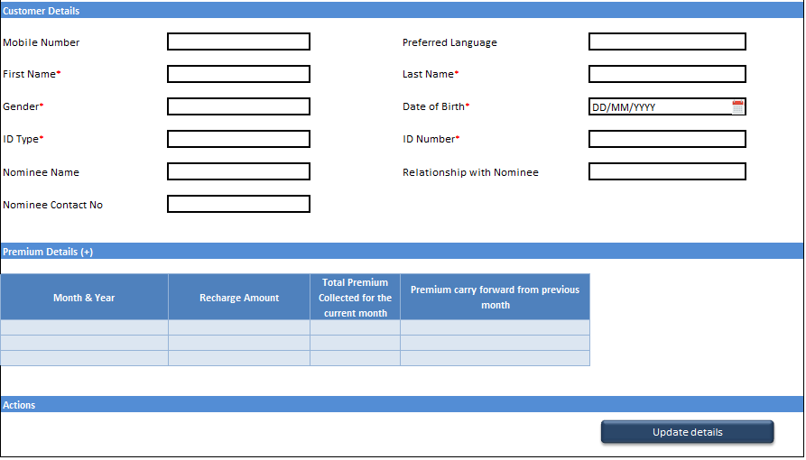

**Decision**

User will have the following decision on the case:

|  |  |
| --- | --- |
| **Decision Title** | **Step Outcome** |
| Approve | Work item will be closed. Data captured in previous step by the agent shall be passed to DB and SMS will be sent to the customer. |
| Reject | Work item will be closed. Data captured in previous will not be passed to DB. |

**User Interface Requirements**

Not Applicable

**Integration Requirements**

Lao Telecom

**Exception Rules**

Not Applicable

**Remarks**

None

# Claims Overview

## Process Specification Diagram

Attached is the End to End Process flow for Claims.

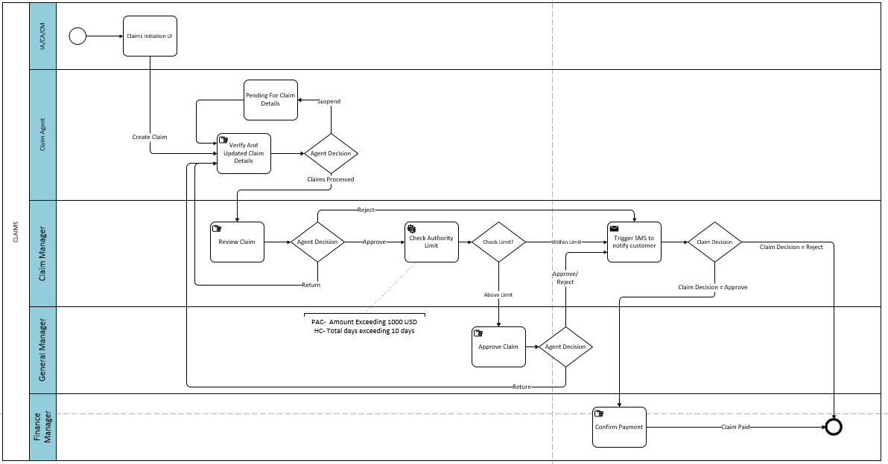

## Roles and Responsibility of Actor

**Process Participants:** List of all participants is provided below –

|  |  |  |  |
| --- | --- | --- | --- |
| **Process** | **Step Name** | **Actor** | **Role** |
| **Claims** | Claims Initiation UI | Manual | Inbound Agent, Claim Agent, Claim Manager |
|  | Verify And Updated Claim Details | Manual | Claim Agent |
|  | Pending For Claim Details | System |  |
|  | Review Claim | Manual | Claim Manager |
|  | Check Authority Limit | System |  |
|  | Approve Claim | Manual | General Manager |
|  | Confirm Payment | Manual | Finance Manager |

## Initiation

Lao Telecom customers will have an option non insurance or insurance linked mobile recharge packages or new connection. Customers are eligible for Disability and Hospitalization claim from 1st day of next month. The coverage depends on the amount with which recharge was done.

# Claims Detailed Requirements

## Manual Step – Claims Initiation UI

**Purpose of this Step**

Purpose of this step is to initiate a claim after receiving a call from the customer.

**Role**

Inbound Agent, Claim Agent & Claim Manager

**Step Description**

1. Call center users will have an option to launch claim initiation UI (sample) as shown below to initiate a new claim.

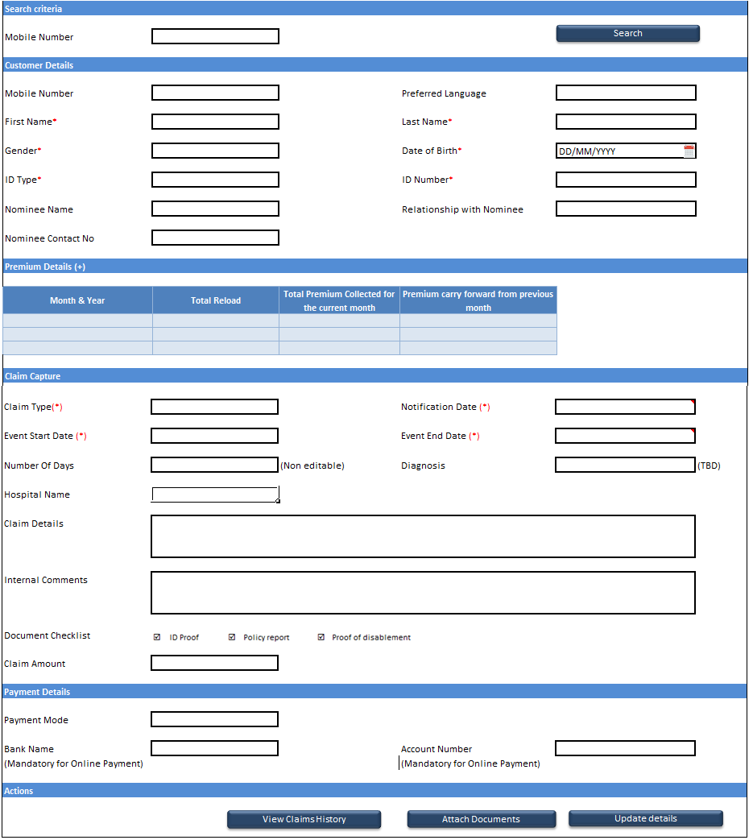

1. The Screen will have the following sections:
   1. Customer Details: Fields will be same as explained in “Update NB Details” step of NB process.
   2. Premium Details: Fields will be same as explained “Customer View and Update” UI.
   3. Claims Capture: Details of fields mentioned in this section are shown below. Until the mandatory fields are entered, user shall not be allowed to click on “Register Claim” button.

|  |  |  |  |  |
| --- | --- | --- | --- | --- |
| **Field Name** | **Type** | **Details** | **Selection** | **Character** |
| Claim Type(*) | Dropdown | Mandatory: Disability, Hospitalization, Death | Mandatory |  |
| Notification Date (*) | Calendar | Mandatory: DD/MM/YYYY | Mandatory |  |
| Event Start Date (*) | Calendar | Mandatory: DD/MM/YYYY | Mandatory |  |
| Event End Date (*) | Calendar | Mandatory: DD/MM/YYYY | Mandatory |  |
| Number Of Days |  | Auto calculate (Event End Date - Event End Date) | Mandatory |  |
| Diagnosis | Dropdown | TBD | Optional | 30 |
| Hospital Name | Free Text |  | Mandatory | 30 |
| Claim Details | Free Text |  | Optional | 500 (per case) |
| Internal Comments | Free Text |  | Optional | 500 (per case) |
| Document Checklist |  | 1. Disability (Documents required ID Proof, Policy report, Proof of disablement)  2. Hospitalization. ( ID proof, Hospital discharge statement (proof of stay)) 3. Death (Documents required- Death certificate, ID Proof, Nominee ID) | Optional |  |
| Claim Amount | Free Text |  | Optional |  |

* 1. Payment Details

|  |  |  |  |
| --- | --- | --- | --- |
| **Field Name** | **Type** | **Details** | **Character** |
| Payment Mode | Dropdown | Online Transfer, Cash, Cheque, Mobile Money, Airtime | 15 |
| Bank Name | Free Text | Mandatory if Payment mode = Online Transfer | 15 |
| Bank Account Number | Free Text | Mandatory if Payment mode = Online Transfer | 16 |

* 1. Action :
     + Attach Documents: When user clicks on the button then a popup will be shown so that agent can add documents related to the customer.
     + Register Claim: After entering details on the screen, user will click on “Register Claim” button so that a work item is created for claim agent for further processing.

1. If data in any field is changed then a case shall be triggered in manual step “Approve Changes in Customer Details”. If data is entered in any field for the first time then the details will updated without any work item creation.

**Decision**

Not Applicable

**Integration Requirements**

Not Applicable

**Exception Rules**

Not Applicable

**Remarks**

None

## Manual Step – Verify and Updated Claim Details

**Purpose of this Step**

When the agent submits the claim details in claim initiation UI then a new claim case will be generated and the case will be assigned to Claim Agents.

**Role**

Claim Agent

**Step Description**

1. Claim Agent will login to Flowable UI.
2. Claim Agent will take ownership of the claim and then clicks on the work item. Below screen will be shown to the user:

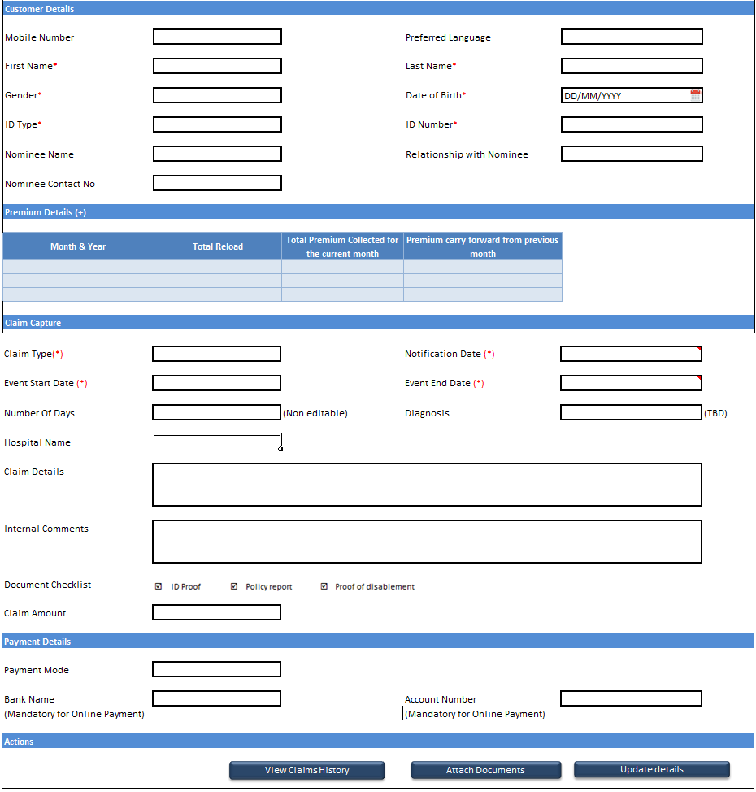

1. Agent shall ensure that before processing the case, all the details are entered on the screen. Details of each field were provided in “Claims Initiation UI” step.
2. A new action is added in this screen i.e. “View Claim History”. When user clicks on the screen then below fields will be shown to the user:

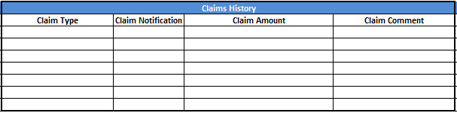

**Decision**

User will have the following decision on the case:

|  |  |
| --- | --- |
| **Decision Title** | **Step Outcome** |
| Suspend | Case will be sent to “Pending For Claim Details” step for the defined period. Feasibility of showing a calendar for suspension needs to be technically analysed and the same will be confirmed after the development phase. |
| Claim Processed | The work item shall be routed to “Review Claim” step for approval. |

**Integration Requirements**

None

**Exception Rules**

Not Applicable

**Remarks**

None

## System Step – Pending For Claim Details

**Purpose of this Step**

All cases for which claim agents have taken “Suspend” decision will be sent to “Pending for Claim details” step.

**Role**

System

**Step Description**

System shall have the capability to allow Agents to manually resume the cases. Once the user resumes the case then it will go back to user’s basket in “Verify and Updated Claim Details” for further processing. Case can also resume once the suspension period is expired. Technical feasibility needs to be done on the suspension and resumption scenario and the same will be communicated to users after the development phase.

**Decision**

Not Applicable

**User Interface Requirements**

Not Applicable

**Integration Requirements**

Not Applicable

**Exception Rules**

Not Applicable

**Remarks**

None

## Manual Step – Review Claim

**Purpose of this Step**

When claim Agents capture all the required details for the claim then it is sent to Claim Managers for review.

**Role**

Claim Manager

**Step Description**

1. Claim Manager will login to Flowable UI.
2. Claim Manager will take ownership of the claim and then clicks on the work item. Below screen will be shown to the user:



1. Agent shall ensure that before processing the case, all the details shall be entered on the screen. Details of each field were provided in “Claims Initiation UI” and “Verify and Updated Claim Details” step.

**Decision**

User will have the following decision on the case:

|  |  |
| --- | --- |
| **Decision Title** | **Step Outcome** |
| Approve | Case will be sent for “Authority Limit Check” step. |
| Reject | Case will be terminated and status will be recorded in database. |
| Return | Case will be sent back to the same Agent who worked on the case in “Verify And Updated Claim Details” step. |

**Integration Requirements**

None

**Exception Rules**

Not Applicable

**Remarks**

None

## System Step – Check Authority Limit

**Purpose of this Step**

When Claim Manager takes Approve decision on a claim then system shall check whether the case is within the authority limit of the manager.

**Role**

System

**Step Description**

1. In this step, system will check the claim based on below condition:
2. Claim Type = Disability/Death and Claim Amount > 88,75,521 Lao Kip or
3. Claim Type = Hospitalization and “No of days” value > 10 days
4. Based on the above logic:
5. If the above condition is satisfied then case will be routed to “Approve Claim” by General Manager.
6. However if the condition is not met then the case will closed and a SMS will be sent to the customer.

**Decision**

Not Applicable

**User Interface Requirements**

Not Applicable

**Integration Requirements**

Not Applicable

**Exception Rules**

Not Applicable

**Remarks**

None

## Manual Step – Approve Claim

**Purpose of this Step**

When claim manager approves a claim then the work item will be assigned to General Manager Role.

**Role**

General Manager

**Step Description**

1. General Manager will login to Flowable UI.
2. General Manager will take ownership of the claim and then clicks on the work item.
3. Claims Assessment screen will be shown to the user (as shown in previous step)
4. Details of each field were provided in “Claims Initiation UI” and “Verify and Updated Claim Details” step.

**Decision**

User will have the following decision on the case:

|  |  |
| --- | --- |
| **Decision Title** | **Step Outcome** |
| Approve | Case will be routed to finance manager and status will be recorded as “Approved” in database. An SMS will be sent to the customer. |
| Reject | Case will be terminated and status will be recorded as “Rejected” in database. An SMS will be sent to the customer. |
| Return | Case will be sent back to the same Agent who worked on the case in “Verify And Updated Claim Details” step. |

**Integration Requirements**

None

**Exception Rules**

Not Applicable

**Remarks**

None

## Manual Step – Confirm Payment

**Purpose of this Step**

Since claim payment will be done in the core system so there needs to be a step for finance manager to confirm whether the claim is paid to the customer.

**Role**

Finance Manager

**Step Description**

1. Finance Manager will login to Flowable UI.
2. Finance Manager will take ownership of the case and then clicks on the work item.
3. Claims Assessment screen will be shown to the user (as shown in previous step)
4. Details of each field were provided in “Claims Initiation UI” and “Verify and Updated Claim Details” step.

**Decision**

User will have the following decision on the case:

|  |  |
| --- | --- |
| **Decision Title** | **Step Outcome** |
| Claim Paid | Case will be terminated and status will be recorded in database. |

**Integration Requirements**

None

**Exception Rules**

Not Applicable

**Remarks**

None

# Report Requirement Scope

Below reports will be built and it will be accessed by specific users based on the configuration:

1. Premium Collection Report
2. NB Exception Report For Missing Data
3. Claims Payment Report

# Report Requirement

1. To extract a report, user will be provided with a link. When user clicks on the link then a UI will be shown where user shall select “From” and “To” dates for which the data will be extracted.
2. During the development phase, it will be decided where there needs to be interval defined between “From” and “To” date. For e.g. not more 6 months data can be fetched at a time.
3. Below are the field details for each report. Exact format of the report will be defined during the design and development phase:
4. Premium Collection Report

|  |  |
| --- | --- |
| **Field Name** | **Details** |
| Mobile Number | (one entry per phone which would be consolidated) |
| First Name | As per the database |
| Last Name | As per the database |
| DOB | As per the database |
| Premium Value | Month By Month data needs to be shown |
| Carry Forward Premium | (exceeded premium which will be carry forward in subsequent month) |

1. NB Exception Report For Missing Data

|  |  |
| --- | --- |
| **Field Name** | **Details** |
| Mobile Number | (one entry per phone which would be consolidated) |
| Package Name | 1st Package ID received from Lao Telecom |
| 1st SMS date | 1st SMS sent from system |
| 2nd SMS date | 2nd SMS sent by system |
| Process/Case Created (Yes/No) |  |

1. Claims Payment Report: There can be multiple records for one mobile number in this report.

|  |  |
| --- | --- |
| **Field Name** | **Details** |
| Mobile Number |  |
| Claim Type |  |
| Claim Notification Date |  |
| Event Start Date | (Filter to extract report) |
| Event End Date |  |
| No of days |  |
| Diagnosis |  |
| Claim Amount |  |
| Claim Status | (Approved /Paid/Pending) |
| Payment Method |  |
| Bank Name |  |
| Bank Account No |  |
| Nominee Name |  |
| Nominee Contact No |  |
| Hospital Name |  |

1. A Process Capability report shall be built which is like a Data Dump where process related audit information will be present. Fields of data dump will be shared during the development phase.